HRNN Example

In the following example, there are 5 processes given. Their arrival time and Burst Time are given in the table.

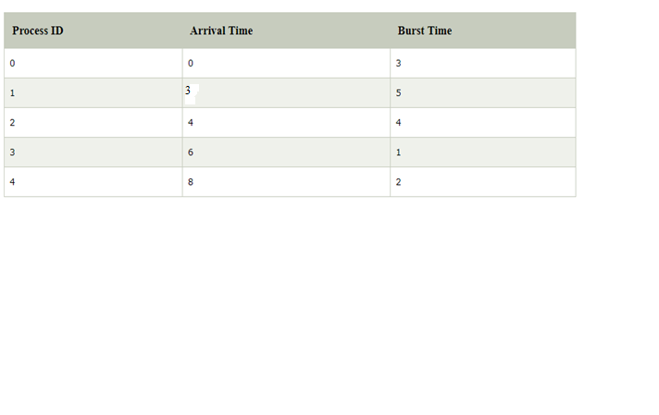

At time 0, The Process P0 arrives with the CPU burst time of 3 units. Since it is the only process arrived till now hence this will get scheduled immediately.

­­­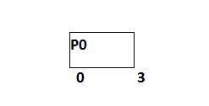

P0 is executed for 3 units, meanwhile, only one process P1 arrives at time 3. This will get scheduled immediately since the OS doesn't have a choice.

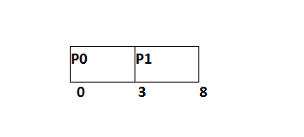

P1 is executed for 5 units. Meanwhile, all the processes get available. We have to calculate the Response Ratio for all the remaining jobs.

1. RR (P2) = ((8-4) +4)/4 = 2
2. RR (P3) = (2+1)/1 = 3
3. RR (P4) = (0+2)/2 = 1

Since, the Response ratio of P3 is higher hence P3 will be scheduled first.

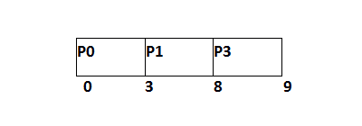

P3 is scheduled for 1 unit. The next available processes are P2 and P4. Let's calculate their Response ratio.

1. RR ( P2) = (5+4)/4 = 2.25
2. RR (P4) = (1+2)/2 = 1.5

The response ratio of P2 is higher hence P2 will be scheduled.

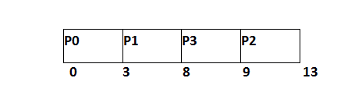

Now, the only available process is P4 with the burst time of 2 units, since there is no other process available hence this will be scheduled.

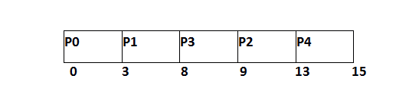

|  |  |  |  |  |  |
| --- | --- | --- | --- | --- | --- |
| **Process ID** | **Arrival Time** | **Burst Time** | **Completion Time** | **Turn Around Time** | **Waiting Time** |
| 0 | 0 | 3 | 3 | 3 | 0 |
| 1 | 2 | 5 | 8 | 6 | 1 |
| 2 | 4 | 4 | 13 | 9 | 5 |
| 3 | 6 | 1 | 9 | 3 | 2 |
| 4 | 8 | 2 | 15 | 7 | 5 |

                     Average Waiting Time = 13/5